1. Click on File -> New File ->R Markdown…
2. Under Title: Enter “Markdown Demo”
3. Under Author: Put your own name
4. Select HTML as the default output.
5. Click “OK”

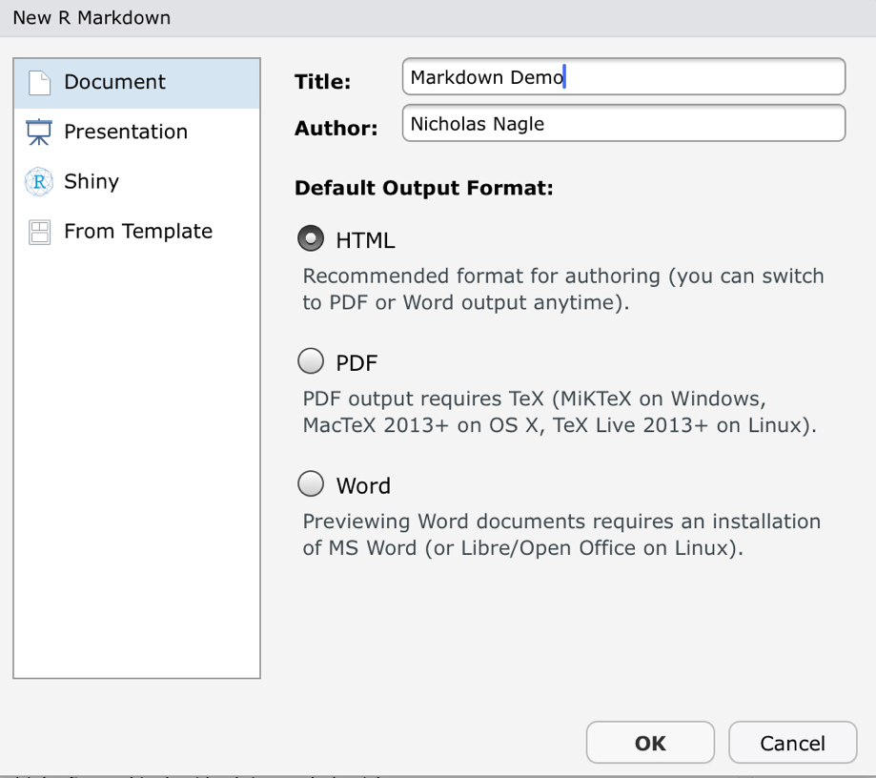

This will create a new document for you in the top left.

Go ahead and click on the button “Knit”. If you get a notice about missing packages, then go ahead and agree to install them.

An R markdown file has three main types of section:

* **1) The header.** Looks like:

---

title:

author:

other stuff

---

Don’t mess with the header other than to change the title and author. It’s best to let the header be autogenerated by R.

* **R code chunks**

```{r, title, other commands like fig.width, fig.height, etc}

Rstuff here

More rstuff here

```

* Plain markdown text.

Everything not in the header or in an R chunk is plain text. The r markdown help tells you how to make sections and lists.

**BEFORE MOVING ON**

Compare the .Rmd markdown text and the html that was generated. Make sure that you can see how every section in the .Rmd shows up in the html file. If you don’t understand, go ahead and ask the TA.